The
Comments on Professor Christfried Jakob's Contributions
made in
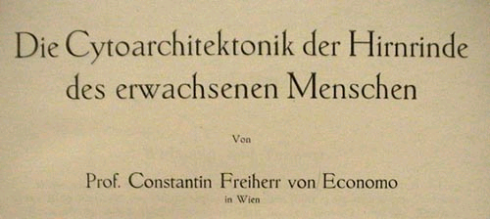
(The Cytoarchitectonics of the Adult Human Cortex)

by

Professor Constantin, Baron von Economo
in Vienna, and
Dr. Georg N. Koskinas
emeritus Assistant of the Psychiatric and Neurological University Clinic in Athens
Created at the Psychiatric Clinic, Director Councillor J. Wagner v. Jauregg
Vienna

Vienna and Berlin
Publisher: Julius Springer Verlag
1925

Translated into English by H. Lee Seldon (Monash Univ., Australia)
who also offers the German text of the entire book with its illustrations, as well as his English rendering (under completion), in his website http://neptune.netcomp.monash.edu.au/staff/lseldon/LeePublications.html

Notes in the present article are by Mariela Szirko

Electroneurobiología 2005; 13 (1), pp. 46 - 73; URL http://electroneubio.secyt.gov.ar/index2.htm

Copyright © Public. This is a research work of public access, with redistribution granted on the condition of conserving this notice in full and complete reference to its publication including URLs. - Esta es una investigación de acceso público; su copia exacta y redistribución por cualquier medio están permitidas bajo la condición de conservar esta noticia y la referencia completa a su publicación incluyendo la URL original (ver arriba).

You can download a .PDF (recommended: 0.8 MB) file for printing, from / Acceso de red permanente: puede obtener un archivo .PDF (recomendado: 0.8 MB) para imprimir esta investigación, de
http://electroneubio.secyt.gov.ar/index2.html

Professors von Economo and Koskinas made their commentaries to refer (Literature, page 803) to
JAKOB, CHR.: Vom Tierhirn zum Menschenhirn, München: Lehmann, 1911
and
Das Menschenhirn [Eine Studie über den Aufbau und die Bedeutung seiner grauen Kerne und Rinde], München: Lehmann [1911].

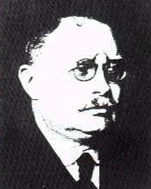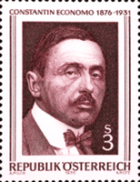

Christfried Jakob (1866-1956) and Constantin Freiherr von Economo (1876-1931)

--------

General part: General basis of the cytoarchitectonics of the cerebral cortex
Chapter 1. Introductory remarks
A. Introduction

(Page 2)
Like the sensory organs (for example, the eye pouches from the mesencephalon), the hemisphere pouches of the cerebrum develop in pairs from the single telencephalon, and one could interpret them as a sensory organ whose view is on the internal events in the central nervous system. The stimuli which enter this organ do not come directly from the periphery, but are merely internal stimuli that come from the entire remaining nervous system, to be received and processed as a total. The cerebral cortex is also capable of accumulating these stimuli, so that the surplus part of stimulus energy, which is not used in the simple reflex arc, collects in the brain. By being able to change past energy into present and future energy, it frees the organism from the brutal primitive law of the reflex act and gives him individual freedom and personality (CHR. JAKOB).
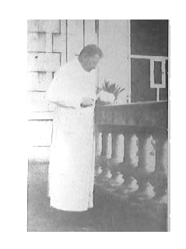
Prof. Jakob sectioning a human brain on the sun-drenched veranda by the South entrance of this Laboratory (right side of the photograph), at the time (1906-7) he was composing his interference model of reverberating macro- and microcircuits for the installments of "Localization of the soul and intelligence". Image added for this article.

B. Historical Notes
Original pagination (from the Table of Contents):
CHRISTFRIED JAKOB Fundamental layers, 20
His “original gyri” and sector theory, 23

[This is from von Economo & Koskinas]: Page 17
Three names must still be mentioned, that, although they are not directly connected with cytoarchitectonics, will still greatly influence its study, namely CAJAL, KAES and CHRISTFRIED JAKOB.

In 1886 GOLGI gave us, with his silver impregnation method for neurons, a unique means to recognize the form of a neuron together with its dendrites and axon. Thus, we can derive basic knowledge about the different cells types which appear in the nervous system. Soon thereafter CAJAL began to systematically explore the human and animal cerebral cortex by means of various silver methods, some also wonderfully developed by him. We owe the knowledge that we have about it today to this highly-deserving Spanish scholar. In the discussion of the individual cell forms in Chapter 2 (cf. p. 44 - 68), furthermore with the discussion of the individual Areas and in many other places we will return to individual results of his extensive examinations. Knowledge of the entire cortical architectonics can help us understand the processes in it only in conjunction with the knowledge of CAJAL's explorations of the structure of individual cells and their precise connections projections. With regret we must register the feeling that CAJAL's great studies were ahead of their time, as he did them before the area division of the cortex was postulated by MEYNERT and BETZ, a postulate which would create the necessary coarse basis for CAJAL's detailed examinations. It is often difficult today to utilize the important results that have been provided by silver stains, because localization of these results to precise positions in the cortex cannot be done. Therefore, CAJAL, with his untiring creativity, has recently started with silver impregnation of the individual "Areae" of the cortex, and we expect extraordinarily important results from these studies, especially for a future fibrillo-architectonics.
In 1907 KAES published a text and atlas on the normal and pathological cortex, stained by means of the myelin method. We want to summarize the most important results here: The cortical thickness is greater in the newborn in the first months of life than in adults; from the third month of life to the end of the first year, it rapidly decreases; the decrease progresses slowly and further until the end of the 20th year of life; around the 20th year it begins to increase again and reaches its maximum in the 5th decade of life, in order to then decrease again. Fig. 13, curve I, p. 21, shows this behavior in excerpts from KAES' original pictures. The gyral cap, the gyral wall and the gyral valley behave rather uniformly here. But not all parts of the cortex participate identically in these alterations. KAES therefore divides the cortex into a so-called outer main layer, including the outer three MEYNERT's layers up to the outer Baillarger stripe, and the underlying inner main layer. KAES's curve II, Fig. 13, shows that the changes of the total cortical thickness are based specifically on fluctuations of the outer main layer, that decreases up to the 20th year and then grows significantly again up to the 45th. Actually, the inner main layer (curve III, Fig. 13) increases progressively but very slowly from birth up to the fifth decade of life. If this observation should prove to be a rule, it would be a fundamental fact of the development of the brain during life, one whose importance is immediately clear to everyone. According to KAES, individual brain regions adhere to this curve quite differently. It is applicable to the entire forebrain; however, it does not apply to the visual cortex - here the development curve shows a more continuous development. In certain brain regions, the peak of the development curve shifts to other ages; and so each brain area apparently has its own curve. In KAES's original work the regional alterations are caused more through the outer main layer than the one. KAES also determined the number of projection bundles per millimeter-wide section of the cortex at different ages. We show parts of his curves in Fig. 14. The maximum is reached at approximately the 20th year; however, again both the number of projection bundles as well as the year of the maximum vary regionally; the cortex of the anterior central gyrus and the visual cortex deviate the most from this average curve. KAES thinks furthermore that the narrower cortex is the more developed and fiber-rich; in the adult this is usually the left side. Because of the particular development pattern and the delayed development peak of the outer main layer (in the 5th decade of life!), KAES believes that it plays a special role in the development of individuality and higher intellect. One objection to the measurements of KAES is that his numbers are too large - he gives an average of 4.9 mm for the width of the cortex at the gyral caps of the convex surface – it should be at most 3.5 mm! - or too inaccurate. Certainly it would be very desirable to control whether the rules formulated by KAES retain their validity after a correction of the measurements. Then it is certain that these rules, particularly regarding the behavior the outer and inner main layers, would be of fundamental importance. With the Gudden method NISSL showed experimentally that only the cells of the inner main layer are connected to the deep ganglia and projection tracks; this discovery also points out a fundamental difference between outer and inner main layers. We shall see how much these layers show regional differences in Chapter 4 (cf. p. 116 - 178)
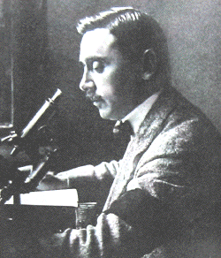
Professor von Economo, early in his career as a scientist
Page 22 (even header): Introductory remarks.
In CHRISTFRIED JAKOB's still unfinished works "Vom Tierhirn zum Menschenhirn" and "The Human Brain" there are quite new results. Although like the aforementioned ones, these are not directly connected with cytoarchitectonics, they can still influence the latter. For the outer and the inner main layers, which he considers the two fundamental layers of the fully developed cortex, through phylogenetic studies and examinations of Gymnophions (Coecilis lumbricoides) - an especially suitable object, with a brain structure between amphibians and reptiles [Note from Jakob's Laboratory, September, 2005: a few years later, Jakob discovered an error in systematics – the supposed gymnophions were actually amphisbaenids! Prof. Jakob treated the error humorously throughout his life and reported it in a series of books and letters, none of which seem to have been known to Professors von Economo and Koskinas by the time of writing their treatise, completed in September, 1924. As the systematic position of his observations was duly corrected, the blunder had no neurobiological consequences. MS] - he could demonstrate a different origin for each layer. We borrow the following explanations and illustrations from his book. With amphibians the cerebrum comprises only the rhinencephalon and the Striatum, and the cerebral pouch that stretches itself over it is still purely ependymal (Fig. 15). With Coecilia [Amphisbaena; MS], where this blanket has already developed to a wider, nervous tissue, the neurons of this formation (Archipallium), that will become Ammon's horn in higher animals, correspond only to the inner fundamental layer. Those at the lateral base of the Archipallium remain in continuous contact with the cells of the Striatum c. st. (Fig. 16a, si). However, at the place (f.m.) where the actual rhinencephalon (Rh) is bordered in the Fissura marginalis, a lateral cells row originating from the cells of this rhinencephalon (se) pushes itself over the cells of the Striatum and the inner fundamental layer (si) and forms the basis of the outer fundamental layer (se). Together they form the ordinary cortex, the neopallium. With embryological studies of the central nervous system of opossums, CHR. JAKOB found places which seem to support this being a general principle (Fig. 16b). (Compare Fig. 66 image VI of the three-month human fetus.) He infers that the outer main or fundamental layer (II + III of MEYNERT) derives originally from the rhinencephalon and is more sensory in nature, whereas the inner fundamental layer (V + VI), which originates from the Striatum, is motor in nature. In later life the two unify through layer IV, whose granular cells form a system of short associations between the two fundamental layers. The cortex of the Archipallium, which remains relatively constant throughout animal phylogeny, forms Ammon's horn. The lateral pouch with the two fundamental layers becomes the neopallium (the actual gray cortex) through strong growth dorsally and medially and through increase in width. The always peculiarly built Insula cortex (with the Claustrum) develops from the area of the marginal fissure. Furthermore, at the base the "rhinencephalon" has its own further development. The neopallium develops immensely from outside to inside and folds itself in longitudinal pleats, the origins of gyri. The most inner one is Ammon's horn, then the Gyrus limbicus and towards the outside - still recognizable as primitive gyri in the dog brain - Gyrus ectomarginalis, suprasylvicus, ectosylvicus and insulae. The Operculum is created through swelling of the cortex edge at the Fissura marginalis. Besides this ventro-dorsal development, a fan-like unfolding of the cortex appears in the frontocaudal direction, with a rotation point in the Insula area. This development causes, beside the above-mentioned segmentation in primitive gyri, a sector-shaped construction along the longitudinal axis. This is still very clear in the cortical structure of lissencephalic animals. Fig. 17 (CHR. JAKOB) clearly shows this. Through further fan-shaped development posteriorly the occipital lobe arises, and through further twisting of this rear end downward and again forward the temporal lobe arises. This is described by the sector diagram of primates (Fig. 18, from JAKOB). Each of these sectors has its own physiological functions and own anatomical connections. A glance at Fig. 18 and on our brain map (Figs. 19 and 20, which we show reduced for comparison) shows a certain astounding similarity of both. The same holds for a comparison of Fig. 17 with the brain map of lissencephalic animals (Fig. 104, p. 243). The future will show whether these new and basic thoughts of CHR. JAKOB on the fundamental layers and the sector development are right. We mentioned them extensively here, because this description of the main layers is closely related to our architectural studies and because it is possible that the similarity of the sector-shaped development and the borders of the Areas that appear on these illustrations, is based on more than a mere coincidence.

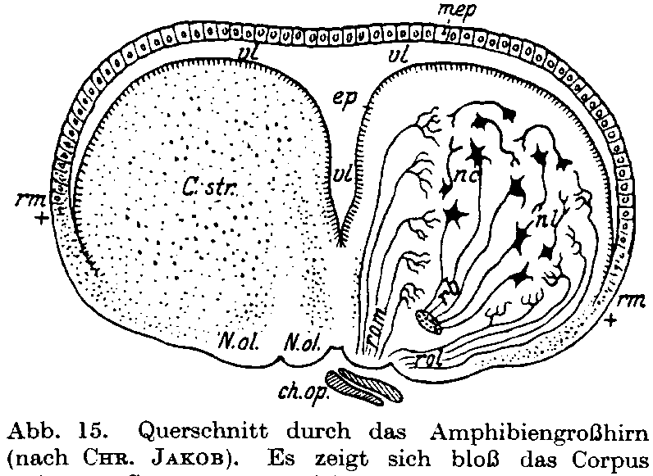

Fig. 15. Cross-section of the amphibian cerebrum from CHR. JAKOB. The Corpus striatum C.str is well developed, while the hemisphere cover (Pallium) appears only as a thin ependymal film mep over the ventricle vl.

Historical Notes (odd-page header): 23

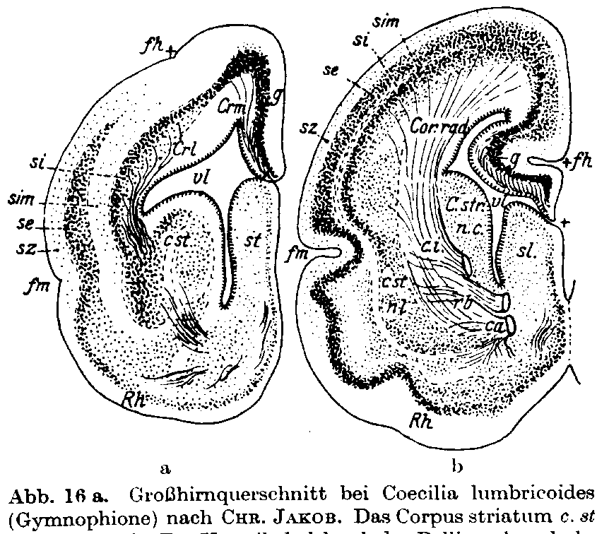

Fig. 16 a. Cerebrum cross-section of Coecilis lumbricoides (Gymnophion) from CHR. JAKOB. [Indeed Amphisbaenidae; see note in text. The misattributed genus' nomen is Caecilia L. 1758, from Pliny the Elder; occasional Coecilia appears from 1790's on] The Corpus striatum c. St is well developed. The Pallium closes the ventricle vl dorsally; it is admittedly thin, but already neurons are present in g (Archipallium). These cells originate from the lateral band of the Corpus striatum and form the Stratum internum si, later to become the inner fundamental layer. Rh rhinencephalon; fm Fissura marginalis is the base of the rhinencephalon. From here a cells row se, the later outer fundamental layer, grows from lateral and basal dorsally over the si. Therefore, se originally comes from the rhinencephalon and later merges with the si, which comes from the Striatum. sz Stratum zonal, sim Stratum intermedium, fh Fissura hippocampi. - Fig. 16b shows similar relations in a cerebrum cross-section of an embryo of the opossum (CHR. JAKOB).

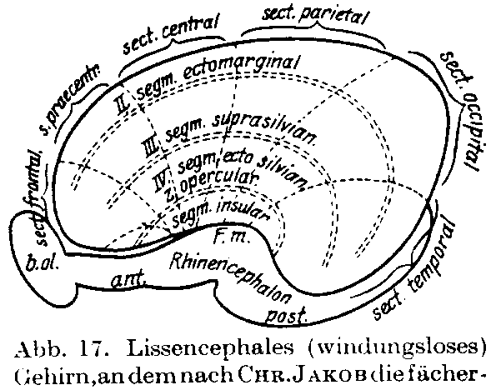

Fig. 17. Lissencephalic brain on which, according to CHR. JAKOB, the fan-shaped development of the sectors in frontocaudal development is drawn. The Insula forms the rotation point of this development. Also the segmental arrangement is drawn.

24 Introductory remarks.

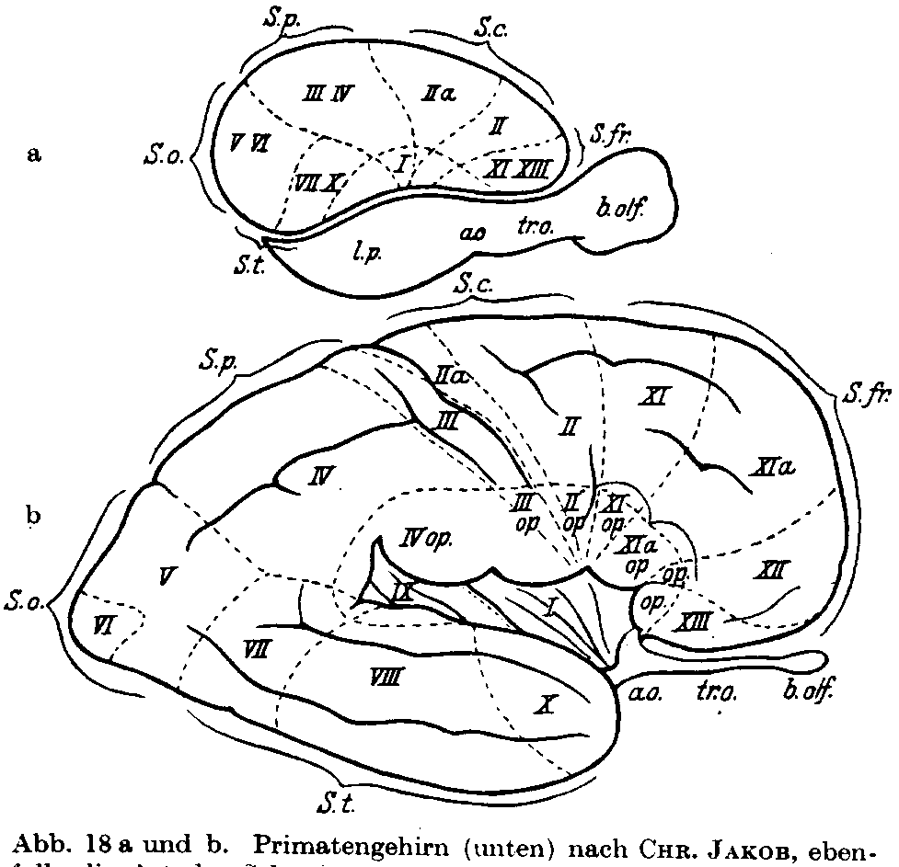

Fig. 18 a and b. Primate brain (below) from CHR. JAKOB also shows the sector development of a sophisticated gyrencephalic brain. The temporal lobe is pushed downward and forwards through the fan-shaped growth, and the occipital lobe is moved to the back. - For comparison a lissencephalic brain is shown above in order to emphasize the movement of the sectors.

All these studies laid the foundations of normal cortex architectonics - for the various purposes and goals discussed above. Major among these was to create the normal basis necessary for recognition of pathological changes, although the study of the latter has taken place simultaneously. BETZ and HAMMARBERG already studied brains from idiots, and KAES included such from criminals. CAMPBELL and later SCHRÖDER made cytoarchitectonic examinations with pyramidal tract lesions and amyotrophic lateral sclerosis. KÖLPIN and LEWY with Huntington's chorea, SPIELMEYER and BIELSCHOWSKY with paralyses without pyramidal tract lesions, JOSEPH, A. JAKOB, BUSCAINO and KLARFELD, DOUTREBENTE and MARCHAND with Dementia praecox (catatonia). ALZHEIMER, BRATZ, POLLACK and KOGERER showed changes in cells and layers with epilepsy. C. and O. VOGT have tried to create bases for a future patho-architectonics in a detailed treatise (Illnesses of the Cerebral Cortex), which also includes numerous good pictures of normal cortex sections. Several detailed publications have appeared from the Viennese neurological institute of Professor MARBURG, under his direction and with the assistance of Dr. POLLAK. They treat the Patho-architectonics of the psychoses systematically and in detail, SAITO on progressive paralysis, TAKASE on manic depression, NAITO on schizophrenia, and OSAKI on senile psychoses. Earlier, WADA had studied this problem in this institute. The first of these works is, as a basis for the judgment of pathological changes, a rich selection of very good photographic pictures of all BRODMANN's fields with a concise and apt description of each. So, we see how pathology awaits with a justified and healthy impatience an exhaustive description of the normal structures of the cortex.

Historical Notes. 25

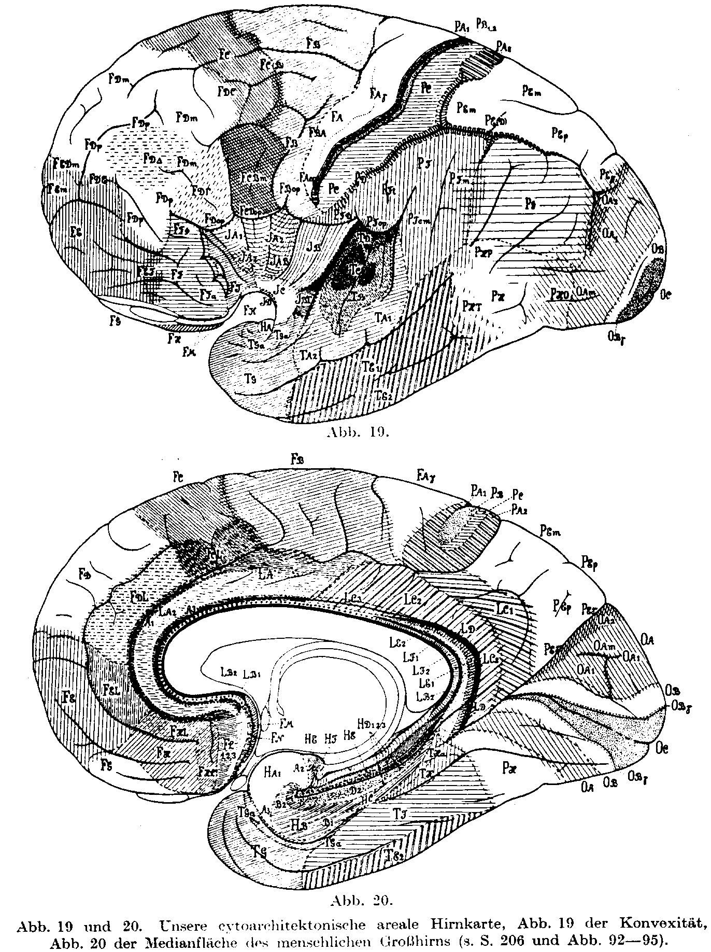

Fig. 19 and 20. Our cytoarchitectonic brain map. Fig. 19 of the convex surface, Fig. 20 of the median surface of the human cerebrum (cf. p. 206 and Figs. 92 - 95).

Cortical measurements Page 41
3. Cortex volumes.
The ratio of gray cortex to white matter volume decreases with higher ranks in the animal phylogeny. We can see this for ourselves through a glance at a brain slice of the rabbit (Fig. 31), in which the gray cortex is extremely broad, and the white matter mass forms only a quite small inner section (cf. Fig. 25 of the human). But even in a comparison of a brain cross-section of a lower monkey, then an orangutan and a human, one is able to see this progressive increase of white matter mass and relative decrease and thinning of the cortex. According to CHR. JAKOB, in cross-sections from lower monkeys the gray matter prevails over the white in the ratio of 5:1; with the Orangutan only by 3:1, and with the human approximately 2:1.
Page 42 General remarks on the cortex and its neurons.
JAEGER has measured the volumes of the gray cortex and white matter of the hemispheres. He determined the volume for brain slices of a certain thickness by means of ANTON's planimetric measurements. He calculated the volume of the cortex of both hemispheres at 540 - 580 cm3, and that of the white matter at 400 - 490 cm3 (without the medulla). On average the ratio would be 560:445 or approximately 1.2: 1. According to DANILEWSKI, the density of the gray matter is 1038, that of the white matter 1043. Therefore, the total weight of cortex substance of both hemispheres would be 581 g, that of the white matter approximately 464 g, and the total of both hemispheres 1045 g (MEYNERT states 1032 g). This corresponds closely to an average total brain weight of 1330 g, whereby approximately 145 g is due to the cerebellum, and approximately 140 g to the brainstem. Of course, the absolute volume of cortex gray matter increases in the animal phylogeny upwards, despite the decrease in the proportion to the white matter. According to CHR. JAKOB, the ratios of cortex gray volume of the lower monkeys to the Orangutan and the human are as 1: 5: 24, since the increase of the whole cerebrum is so great. (The brain of a full-grown Orangutan weighs approximately 500 g, with brainstem and cerebellum.) JAKOB could not find a conspicuously regular difference between right and left hemisphere cortical volumes. The left to right ratio was in one case 290:250 cm3, but many times the cortex gray volume of the right hemisphere was greater than that of the left.
Page 44 General remarks on the cortex and its neurons.
In HENNEBERG's table the beautiful surface development of the Hottentott and Javan brains are very notable, often surpassing the European brains - a warning against deriving rushed conclusions from such data. WAGNER found 54,000 mm2 for the surface of the full-grown orangutan brain, 21,000 mm2 of it free surface and 33,000 mm2 hidden. CHR. JAKOB gives the ratio of the total cortical surface of the monkey to the Orangutang to the human as 1:5:17.

Page 86 Structure and development of the cortical laminae.

Table of the laminar divisions of various authors

 | Our division | KÖLLIKER 1855 | BERLIN 1858 | MEYNERT 1868 (BETZ 1881) | BEVAN LEWIS 1878 (HAMMARBERG 1895) (BRODMANN 1902) | CAMPBELL 1905 | MOTT 1907 | CHR. JAKOB
Outer main layer | I. Molecular layer  Lamina zonalis | 1. superficial white layer | 6. layer without cells | 1. Molecular layer | 1. sparsely populated layer [plexiform layer, Lamina zonalis] | 1. plexiform layer | 1. Zonal layer | 1. Stratum supra-pyramidale | Stratum  supra-pyramidale
Outer main layer | II. outer granular layer  Lamina granularis externa | 2. gray layer | 5. outer dense layer of small pyramidal cells | 2. outer granular layer | 2. small pyramidal cells [Lamina granularis externa] | 2. small pyramidal cells | 2. small, middle, and large pyramidal cells | 2. outer fundamental layer.  (äußere Fundamentalschicht) | Stratum pyramidale
Outer main layer | III. outer pyramidal layer  Lamina pyramidalis  a, small pyramids | 2. gray layer | 5. outer dense layer of small pyramidal cells | 3. Pyramidal layer | 3. large pyramidal cells [Lamina pyramidalis] | 2. small pyramidal cells | 2. small, middle, and large pyramidal cells | 2. outer fundamental layer.  (äußere Fundamentalschicht) | Stratum pyramidale
 | b, medium-sized pyramids | 2. gray layer | 4. lighter layer of larger pyramidal cells | 3. Pyramidal layer | 3. large pyramidal cells [Lamina pyramidalis] | 3. medium pyramidal cells | 2. small, middle, and large pyramidal cells | 2. outer fundamental layer.  (äußere Fundamentalschicht) | Stratum pyramidale
 | b, big pyramids | 2. gray layer | 3. inner denser layer of small cells | 3. Pyramidal layer | 3. large pyramidal cells [Lamina pyramidalis] | 4. large pyramidal cells | 2. small, middle, and large pyramidal cells | 2. outer fundamental layer.  (äußere Fundamentalschicht) | Stratum pyramidale
Inner main layer | IV. Inner granular layer  Lamina granularis interna. | 3. inner white layer | 3. inner denser layer of small cells | 4. inner granular layer | 4. inner small pyramids [Lamina granulosa interna] | 5. stellate cells | 3.Granular layer | 3. Stratum intermedium | Stratum pyramidale
Inner main layer | V. ganglion cells layer  (deep pyramidal layer)  a, upper part | 4. gray-reddish layer | 3. inner denser layer of small cells | 5. Spindle cells layer | 5. ganglion cells layer [Lamina ganglionaris] | 6. inner large pyramidal cells | 4. inner layer of polymorphic cells | 4. inner fundamental layer  (innere Fundamentalschicht) | Stratum pyramidale
 | b, deeper layer | 4. gray-reddish layer | 2. lighter layer of large cells | 5. Spindle cells layer | 5. ganglion cells layer [Lamina ganglionaris] | 6. inner large pyramidal cells | 4. inner layer of polymorphic cells | 4. inner fundamental layer  (innere Fundamentalschicht) | Stratum pyramidale
Inner main layer | VI. Spindle cells layer  a, upper part | 4. gray-reddish layer | 2. lighter layer of large cells | 5. Spindle cells layer | 6. Spindle layer (Lamina multiformis) | 7. Spindle cells | 4. inner layer of polymorphic cells | 4. inner fundamental layer  (innere Fundamentalschicht) | Stratum sub-pyramidale
 | b, deeper part | 4. gray-reddish layer | 1. Layer of big spindle cells | 5. Spindle cells layer | 6. Spindle layer (Lamina multiformis) | 7. Spindle cells | 4. inner layer of polymorphic cells | 4. inner fundamental layer  (innere Fundamentalschicht) | Stratum sub-pyramidale

Page 106 Developmental bases of the lamellar cortical structure.
One sees from Fig. 66 that the embryonic transition from the Isocortex, with its clearly developed pyramidal layer, to the Allocortex, with its anlage of loose cells agglomerations, is a rather sudden one, but the border (a and b) does not have a fixed position, and there are transitional formations at the borders. In adults it is possible to distinguish clearly between the structure of the isocortex and that of the allocortex. However, the borders on the isogenetic side are quite varied, and on the other hand they may still show the six layers sufficiently clearly to complicate their categorization as allocortex. One is often in doubt as to which formation one should consider such a border region. The Allocortex striatus, which we mentioned earlier, usually forms such a border formation, and in its embryonic development we find the reason for this ambiguous position. In the later discussion of the Areas we will see that the borders around the Uncus, the remaining hippocampus, the retrosplenial parts of the Gyrus cinguli, the Area parolfactoria and other places are often unclear. Due to this, it is probably a thankless task to try to correlate the cells layers which later form the allocortex with the usual six layers of the isocortex, or with part of them. The anlages are quite different, and maybe the later apparent similarities are only superficial. Recently, significant studies by CHR. JAKOB have

raised quite new points of view, which we mentioned briefly in the last paragraph of chapter 1 (cf. p. 22). JAKOB studied Gymnophiones [indeed Amphisbaenas, cf. Note from Jakob's laboratory close to the beginning. MS], a type which occupies a middle position between reptiles and amphibians. He showed that the cells groups which first appear in the dorsal wall of the Gymnophion [Amphisbaenid: MS] hemispheric pouch, and which later populate the cortex, are in continuous contact with cells groups of the Corpus striatum. However, the top of the Gymnophion [Amphisbaenid: MS] cerebral pouch corresponds merely to Ammon's horn in other animal species; otherwise, the cells layers correspond only to the so-called inner main layer of the isocortex, i.e., layers V + VI. In Gymnophion [Amphisbaenid: MS] a new lamina develops from the rhinencephalon and grows dorsally and finally medially over the lateral side of the hemisphere, covering those cells which derive from the Corpus striatum (Fig. 16 a and b). JAKOB correlates this phylogenetically later developing layer with the outer main layer of the developed brain, while the lower layer corresponds to the inner main layer. The outer "fundamental layer", as he calls it, finds its phylogenetic origin in the rhinencephalon, and is continuous with that outer cells layer. The inner "fundamental layer" derives phylogenetically from the Corpus striatum, with whose lateral nuclear layer it is connected. However, Ammon's horn is merely the direct continuation of this inner fundamental layer. According to JAKOB, it completely lacks the outer cells layer – as it does throughout the mammalian species, including humans. Fig. 16a shows this relationship in Gymnophions [Amphisbaenas: MS]. In the embryonic development of the brain of the opossum JAKOB could also prove this connection of the two fundamental layers with their original places, as Fig. 16b shows. The two fundamental layers join together, and their joint corresponds to the intermediate granular layer (our layer IV). This opinion has much that speaks for it. The embryonic development, the ontogenesis of the human brain no longer shows such a principal difference of the origins of the lower versus the upper layers, since the anlage of the whole cortex is built by migration of all neuroblasts from the underlying matrix. However, it is possible that the ontogenetic development only imperfectly reflects the phylogenetic stages, and that the migratory precursors of the inner and outer layers already occur in the germinal anlage, skipping the intermediate stages. If this brilliant opinion of JAKOB is really true, then it is correct for us to identify the cells of part of the allocortex, that is Ammon's horn, with the innermost two cells layers of the isocortex.

Structure of the isocortex. Page 115
... We will use these ratios for the wall thickness merely as comparison values, from which one might in some cases find something noteworthy. For example: layer III visibly loses thickness in the wall, yet, as seen above, gains relative width from 33% at the cap to 37% on the wall, an increase of 4%. In certain areas of the cortex, however, this difference is much greater; in the Gyrus rectus layer III gains 10%, so that it even appears to narrow at the cap, rather than widen as usual.

These alterations of the layer thickness, which usually appear on the walls of each gyrus, are not caused mechanically by the curvature of the gyral surface, but they have quite special meanings due to the nature of each layer. The quite colossal increase of layer VI at the cap, giving it a wealth of spindle cells, and the nearly complete absence of layer VI and thus of spindle cells in the valley, as well as the significant decrease of layer V from the cap to the valley – together showing the reduction of the whole inner main layer in the sulcal depths - certainly has a correlate in the different physiological functions between cap, wall and valley (cf. this chapter, paragraph 5, p. 184). Each individual gyrus becomes an individual organ, that consists of different and differently structured parts, since every anatomical difference must of necessity have certain physiological consequences. If one accepts this, then the respective individual sizes, courses, connections with other gyri vía so-called bridging gyri - in short the whole gyral architecture acquires a quite different meaning than has been attributed to it until now. One cannot consider it as a coincidence, as has recently and repeatedly happened due to an overestimation of the micro-architectonic of the cortex, although the study of gyral architectonics has unfortunately until now shown few positive successes. Gyral structure leads us to suspect that it must have a special meaning, which we do not yet know. If one considers the inner main layer as a primarily efferent layer, like CHR. JAKOB (Chapter 2, cf. p. 22), and the outer as receptive or associative, then this would throw some light on the meaning of the structural differences between wall and cap. In future discussions on the formation of the gyri one will have to take these factors into account, since on this occasion they must play a crucial role. One sees the individuality of these structural differences even where one does not think that it could really be a wall formation because of further wall developments or possible secondary gyral formations. For example, the Heschl gyri are only secondary transitional gyri, between the parietal and temporal lobes, which lie on the dorsal surface of the first temporal gyrus, the so-called Sylvian Surface. Throughout life they carry the marks of a gyral wall in their general cellular structure and in the narrowness of layers V and VI, which form a narrow stripe, even at their caps. There are similar circumstances in the cuneo-parietal transition gyri at the posterior wall of the upper parietal lobe in the Sulcus parietooccipitalis, and elsewhere. Furthermore, it is probably no coincidence that in gyrencephalic animals the so-called sensory cortex nearly always develops in gyral walls, such as in the posterior wall of the Rolando Sulcus, in the dorsal wall of the first temporal gyrus, in the wall of the Calcarina and in the interior wall of the Gyrus cinguli. We know from above that the outer receptive main layer prevails in the wall over the efferent layer, which decreases greatly here (cf. also footnote p. 228).

Page 156 Details of the composition and meaning of the lamellar cortex structure.
Layer V shows a quite particular behavior in the frontolimbic transition regions of the median surface (Plates XVII, XXVI, XXXVIII, XXXIX), in the Gyrus rectus and in the anterior part of the Gyrus cinguli (Plates XLV and XLVI), and especially in the anterior Insula (Plate LIV). Here layer V or at least the upper part attains such a density, through an increase of the cell numbers with good cell sizes, that it forms a band through the cell picture of the cortex. Figs. 79-80 represent this approximately through the density of the hatching in a radial direction. This formation is so conspicuous and clear in the anterior Insula that we would like to call it the Insula belt, since it immediately distinguishes the cortex of the anterior Insula, especially in thicker sections. The significance of this "overdevelopment" as a cells band is still quite uncertain. Maybe the corticofugal fibers to the thalamus originate here, as such emanate especially amply from the median surface. This conspicuous cells band in the upper part of layer V is located, as one sees, in areas near the so-called rhinencephalon; in almost all such areas, other than those quoted above, it is indicated but less intense, also in the edges of the hippocampus (Plate CX). Besides this peculiarity, layer V shows some other peculiarities at the cortex rim, to which we want to return later. In relation to the "rhinencephalon" and its nearer and further surroundings, layer V seems to play a not quite comprehensible role, in which apparently its phylogenetically common origin with layer VI in CHR. JAKOB's (cf. p. 22) “inner fundamental layer", the original and only lamina of the Archipallium (from which Ammon's horn then develops), has a deeper meaning.

Page l68 Details of the composition and meaning of the lamellar cortex structure.

This leads us to the question about the relationships of layer V with the allogenetic Cortex. ... Such pictures seem again to confirm BRODMANN's assumption, who after detailed study, also at animals, thinks that merely layer VI takes part in Ammon's horn. Maybe however this issue has less importance than we today generally attribute to it. A cortex layer is not formed anyway at this place in the embryonic brain (cf. p. 104 - 108), like as it occurs in the Neocortex; therefore not either two fundamental layers, as CHR. JAKOB puts it, or two steps, as LANDAU says and as they find in the anlage of the Neocortex. But one single rung develops here; it is almost certainly that these neuroblasts that form the Ammon's horn are closer by their nature to the cells of the V than of those of VI, after which they form beautiful, big, very slender pyramidal cells, as we otherwise are accustomed to see in V. Here, elucidation must come from more detailed embryological and phylogenetic studies.

Structure of the isocortex Page 177
We have already mentioned in Chapter 1, p. 22, the opinion of CHR. JAKOB that together the V + VI forms this "inner fundamental layer"; LANDAU joins this opinion and calls them "inner rung", and seems to assume that the whole "inner rung" continues into the Ammon's horn, while as indicated BRODMANN assumes this from VI alone.

Anyway, layer VI is with the I the most constant in humans; it is excellently developed, as we saw. Its upper part alone, VIa, amounts on average to 22% of the cortical thickness! The whole VI is always the widest layer of the cortex, with exception of quite certain places (for example the Koniocortex and surroundings) and with the VIb usually amounts to virtually 40% of the actual total cortical thickness in humans. We already saw earlier that some authors mean that the width of V + VI grows as one goes further downward in the animal row; against this, BRODMANN points out that some low mammals (small rodents and insectivores) admittedly possess a notably wide layer of spindle cells (for example rabbits), but on the other hand also superior mammals and the primates exactly under the human level have a relatively very wide layer VI; furthermore also some low clans have a very narrow layer VI (kangaroo). It therefore is not generally right to say that the width of the most inner layer increases with low animals! How it was already mentioned once, BRODMANN thinks also that one could merely say that generally in the lower animals the inner main zone, IV + V + VI, possesses in average a relatively larger width than the higher. In order to be able to assess such circumstances, our tables should in the future show also the corresponding relative ratios of the layers, i.e. their proportions for homologous cortical locations in the animal row.

Structure of Isocortex. Page 181
5. Physiological meaning of the layers.
Although our task is concerned with the bare morphology, yet at this place we must touch, even if briefly, the question of the particular function of individual layers. It probably is tightly connected with the question of the physiological hierarchy of individual cells, about which we have already talked in the second chapter section B, together with the description of the individual cells types; and, furthermore, with the question of the fiber- and fibril architectonic, which is outside our examinations. For that reason, by the sole means of cytoarchitectonics we could not solve at all this question as we want; yet we merely wish to remind of some possibilities that come from this study of architectonic. Many times it was attempted to attribute determined functions to the individual layers, an outlook which probably finds eloquent expression in the sentence recently pronounced by VAN VALKENBURG, affirming that the cortex consists of six joined peel-organs nicely imbricated in one another; also JAKOB and VAN'T HOOG tend to a similar opinion. Against this opinion, it uses to be remarked that the individual layers do not consist merely of a single cell type each, but often from very different cells which probably have all their particular significance. Additionally, one must consider that for example the big- and giant-cellular layer V in the anterior central gyrus and the layer of the smallest cells, V, in the parietobasal and occipital region present such a different look that, if from cell composition a deduction regarding function is at all admissible, one can hardly assume that the layers V can have one and the same function in these two regions; so that therefore they do not represent the same "organ". The same is applicable to the layer VI of these areas. Nevertheless, even with full appreciation of these very justifiable objections – which in any consideration of this question will never be allowed to forget – one cannot still disregard that in the predominant part of the cortex the molecular layer, the pyramidal layer, the granular layers, the ganglion cells layer and the spindle cells layer constantly repeat themselves in a manner very similar; and that, even if each of them is itself composed from several individual cells types and cells layers, each layer is however composed to the main part of only one cell type; this fact already finds expression in the layer's name, too. One will therefore be also entitled, at least in a certain sense, to search for a main function of the individual layers, whereby it can become reputed, so that any other function of the same layer may be usually held as additional, notwithstanding that exceptionally some additional function could itself become the main one. Very far, though, our present knowledge of this area do not yet lead us.

Structure of the isocortex. Page 183

By reason of phylogenetic studies, according to which layer III appears as the phylogenetically most recent one, KAPPERS assumes that layer III serves the higher interregional associations. Layer IV (granular layer) has receptive functions, that serve infra-granular layers (V and VI), as origin of the projection fibers as well as the intra-regional association.

CHR. JAKOB has a similar opinion. We have already discussed in some detail his studies and his conclusons (Chapter 1, p. 22 ff), and therefore refer again here on what was said there, from which here we merely repeat: that the upper fundamental layer (II + III) according to its opinion has above all a receptive (sensory) function, the inner fundamental layer (V + VI) being mainly motor (efferent) while the internal granular layer IV forms a system of short associations between these two fundamental layers.

Through isolation of the cortex of the hemisphere from the deeper centers, NISSL proved with the old method of Gudden that, actually, only the inner layers V and VI stands in connexion with the deep centers, thalamic nuclei, etc. With it, as BRODMANN rightly says, a fundamental difference in function is proved between the outer and the inner layers of the cortex' breadth.

FINES, on reason of experimental sections of the corpus callosum, assumes that layer V gives origin to the callosal fibers, while CAJAL, as mentioned, puts for it layer IIIa.

As much different as all these opinions firstly seem, yet they share many points of contact. For example, that the V and VI are looked at as primarily effector layers by all most recent authors. Therefore, it would also correspond that at the sensory places of the brain, that is in the so-called koniocortex, the layer V as well as the VI be quite weakly developed; and in fact specially the first is sparsely populated, while the latter is specially narrow. On the whole, behind the Rolandic sulcus layer V and furthermore layer VI do develop less than in the forebrain where the motor functions are localized. In T2 and T3, nevertheless, the V and VI do again nicely develop (from here after MONAKOW the temporopontine tract should originate). However one cannot forget that also the development of layer III has their optimum in the frontal brain!

To clarify the role that the granular layer probably plays – which KAPPERS considers as purely receptive and CAJAL (and CHR. JAKOB) as providing intracortical connections between adjoining cortical areas and layers – we would like to add the consideration that, as we saw in Chapter 4 (p. 150), layer IV can admittedly consist of very different cells, all of which, probably, could hardly have the same meaning. All the same, those small cells appear in colossal amounts in the cortical areas that, as we still will see later, represent centers of the sensory cortex, which therefore - in the koniocortex of the centralis posterior, Heschl, calcarina, retrosplenialis and hippocampus – present themselves simultaneously with an important increase (cf. p. 191) in the exogenous fibers and the plexuses (in Va) from afferent fibers which (as can be taken from CAJAL's impregnations) usually extend themselves under the IV. This anatomical circumstance suggests that the small cells above all, and specially those of the inner granular layer, must play an important role in the receptive functions of the cortex; in particular, when they immediately receive stimuli from the sensory fiber networks of Va, as already MEYNERT assumed it too (1).
--- [footnote p 184] (1) That on occasions precisely in the sensitive Koniocortex itself layer IV can be missing (for example, in hippocampal granular HD), does not change anything at this opinion, since the other layers are "granulated" at these places.
General anatomical discussion of the Areas. Page 225

§2. Relationship of the areas' borders to the sulci and gyri.
We have just remarked that the areas' borders, in spite of their often being chaotically laid by the course of sulci and gyri, many times crossing and overlapping as already half a century ago BETZ did nicely know, in the frontal lobe for example proceed horizontally, in such a way that the first and second frontal sulci divide the forebrain into three big, horizontal frontal gyri, pulling the Areas borders of FA, FB, FC, FD and FE a little backward and downward (from front above to back below) and thus partition the cortex into nearly sector-shaped Areas: compare Chapter 1, p. 23 CHR. JAKOB. On that juncture the borders of the Areas against each other can just proceed crosswise as well as alongside in the middle of a cap, or either the cap of a gyrus can be covered by an Area while the gyral wall belongs to another Area. Furthermore, as we want to discuss still later, the borders of these Areas show some individual dislocations. This connection – seemingly altogether lacking for some Areas – between tiling and cleavage of the cortex has recently led to a strong underestimation of the meaning of the brain's gyral formations. First and foremost, this remarkable paucity of connectionships between Areas and gyri of the brain is not without exception; one can express this divergence by saying that the sulci do not represent areal restrictions at all or do it only in the rarest cases. In contrast, however, the localizations of a whole series of well determined cortical formations are tied in to quite certain gyri or sulci, their borders varying only in small degree. This, for example, is applicable to the allocortex of the whole so-called "rhinencephalon", which represents an individual and peculiarly built formation, and to some extent also to the isocortex.

Page 226 Area division of the cortex.
The anterior wall of the Rolando Sulcus, as well, and in ventral-dorsal direction also increasingly the cap of the anterior central gyrus, is always the seat of the Betz giant cells, the Area gigantopyramidalis, so that always the Rolando fissure clearly separates two quite different architectural areas of the Centralis anterior and Centralis posterior. Just as constantly, the delimitation of the occipital and parietal cortex to the Sulcus parietooccipitalis is at the median surface. … This points out that between cortex construction and gyral construction, and probably not only with respect to the primary fissures and constant sulci but, maybe, also regarding the remaining sulci and gyri and their form, it must exist a not entirely opaque connection, whose exposition is reserved to future research and in which CHR. JAKOB's picture of the sector-shaped growth, that is the fan-shaped development of the cortex on the one hand and the lengthwise folding (primordial-gyri formation, Urgyrussbildung) on the other hand, probably corresponds to its fundamental process (cf. p. 23).
Page 240 Area division of the cortex.

Besides the above discussed granular Areas of the koniocortex, we have to look at the more distant, specifically highly varied agranular Areas FA and FB situated before the Rolando Sulcus. In these Areas, a transformation of most cells to pyramidal cells takes place with nearly total loss of the granular layer, and the whole area becomes characterized by a special size of the pyramidal cell; even facing the whole remaining brain, the back part of the Area on the anterior central gyrus is outstanding by reason of the well known development of Betz giant cells. Already MEYNERT thought that this exceptional development of the pyramidal cells was to be assumed as the expression for the motility, and BETZ did the same since his giant cells' discovery, which cells he regarded as specifically motor elements; the clinic and the experiment have generally found this assumption right. However, the large pyramidal cells of the IIIc and V layers, which one can regard as responsible for the motility, reach out over the two agranular Areas: in point of fact, over the weakly granular Area FC and, caudalward, the also granular part of FD, which we call FDm; as well as over the whole third frontal gyrus until their orbitary part, which in the foot already is by and large granular, namely FBCm, FDΓ, and FF. VOGT's new classic examinations, in which he simultaneously took into account the architectural structure of this cortex and the effect of its electric experimental stimulation, allowed him to ascertain some alterations of the motor stimulation effects that go parallel with certain alterations of the cortical cellular structure; a closer look of it we give later, with the quite detailed discussion of the physiology of individual Areas (Chapter 7, A, 3, §7, and Chapter 10, A, 5 §7). As it seems, one can say that as immediate effect of stimulation the Area with giant pyramids arranges tonic special movements, whereas FB primarily excites somewhat more severe tonic special movements as well as so-called attitude movements (whole complexes). At any rate, it is interesting to see in this example of the motility that a qualitative alteration of the motor effect corresponds to an anatomical alteration, and that the pyramid cortices FA and FB seem to be, specifically, the motor efferent cortex. As well the leading Areas of large pyramidal cells, FC, FDm, FDΓ, perhaps also FF, seem to have motor effects, besides others. But motor effects from stimulation are also to be achieved from the posterior central gyrus, Area PC; from the upper parietal lobe, Area PE; and elsewhere. A point is to be taken for sure, anyway: pathology teaches us that human motility depends in such a way on the forebrain that motility is not at all possible without forebrain, while the monkey must, rather, be without cerebrum in order to render motility not possible anymore. The progressive removal upward of the sway of the neural axis' centers reached its maximum in the human and shows the conquest of the whole motility by the cerebrum (JAKOB); in the colossal development of the forebrain, this conquest expresses itself, both as regards the regulation of the whole organism and in the particular control of the motility of certain individual parts. One may compare the size of Areas FA, B, C, D, Fig. 92; or fields 4, 6, 8, 9 of BRODMANN Fig. 6 in the human, with those in the monkey, bear and rabbits on Fig. 100 and 101, 102 and 103, 104 and 105, 106 and 107 that are taken from BRODMANN's localizations.
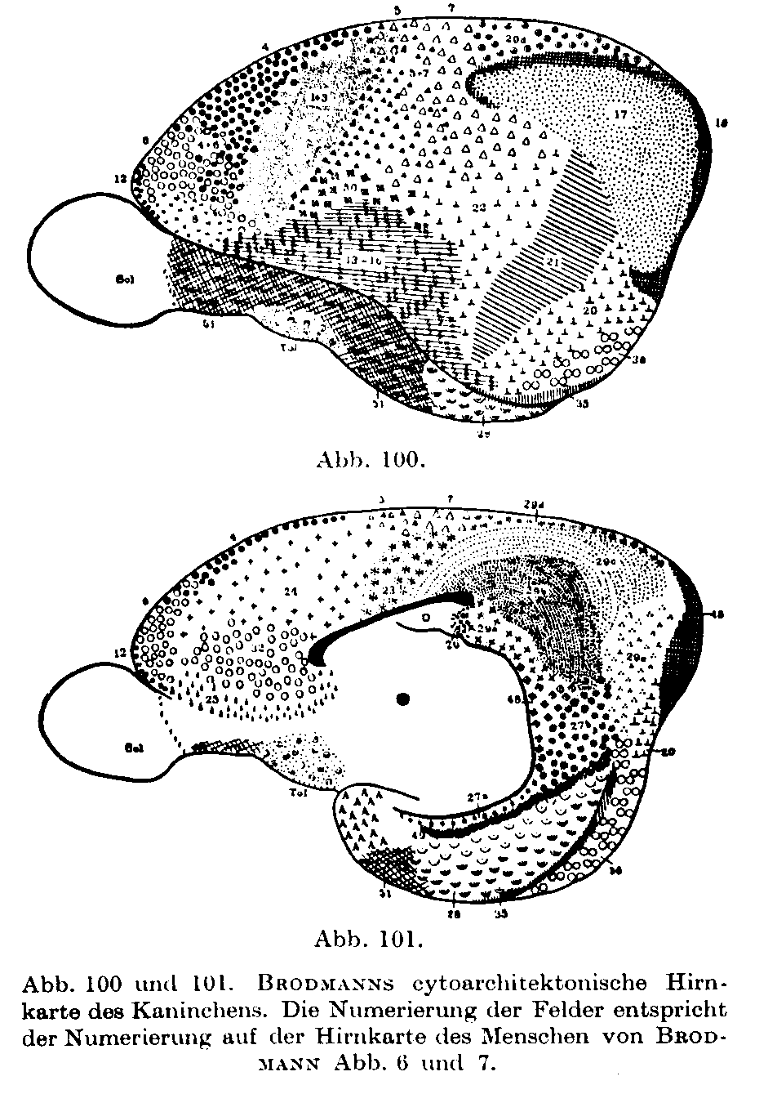

Fig. 100 and 101 [previous page]. BRODMANN's cytoarchitectonic brain map of the rabbit. The numbering of the fields corresponds to the numbering on the brain map of the human of BRODMANN Fig. 6 and 7.

Page 290 The forebrain.

Also some pathological results speak in behalf of what we have already pointed out, namely that the Betz giant cells primarily stand in the immediate context of the motor function. So, in amyotrophic lateral sclerosis simultaneously with the degeneration of the pyramidal tract one finds, also, a complete dwindling of the Betz giant cells from the cortex (CAMPBELL, SCHRÖDER, ROUSSY and ROSSY). Yet, we know from our own experience and from CAMPBELLs examinations that in this pathology also the remaining pyramidal cells, especially those of layer IIIc and the large pyramidal cells of layer V, are completely missing, and that this atrophy of the Lamina ganglionaris can even encroach into the Area FB frontal to it (SCHRÖDER, JAKOB, BUSCHER, among others). Later on, the atrophy even encroaches on the cells of the IIIa and layer IIIb. Furthermore, CAMPBELL found a change in the Betz giant cells of people to whom an extremity had been amputated long time ago. He found these cells swollen, poor in branches, with their Nissl bodies to some extent lost, and with the nucleus eccentrically laid and no longer globular – an alteration that one must call reaction par distance; a particular decaying of the cells that of course he did not find in amyotrophic lateral sclerosis. Unfortunately CAMPBELL omits, as he himself says, keeping an eye on the other cells of the cortex in such amputation cases.

Area praecentralis. Page 291
… VOGT means with NISSL, CHR. JAKOB (cf. Chapter 1, p. 22), and FOERSTER among others, that only the layers V and VI send the projection fibers out, whereas as above said CAJAL as well as ourselves view the large pyramidal cells of the IIIc and V layer as the places of origin of these fibers, at least as regards the pyramidal tract. Still the first opinion is supported, in addition, by BIELSCHOWSKY's, LENZ's and SPIELMEYER's examinations of the so-called "paralyses with intact pyramidal tract". In these innate syndromes the III layer of the cortex is nearly completely missing. These researchers hence assume that layer III could not be the origin of the pyramidal tract, as despite the big reduction in cell numbers that layer III offered in these cases, the pyramidal tract seems anatomically intact; they rather assume that the giant cells of layer V must mainly send the pyramidal tract fibers out, since in these cases no anatomical changes have ever been pointed out in the pyramidal tract itself. …

Page 336 The forebrain

1. Area frontalis granularis FD (Plates XIX - XXX).
The formation extends itself also from the Sulcus callosomarginalis at the median brain wall over the edge to the median cortical surface and the convex surface of the brain down into the Sylvian fissure and, frontalward, basal though partially as far as into the orbitary surface of the forebrain. It therefore forms on the whole another wide belt-shaped zone, that lies directly poleward from the FC formation. The forebrain pole even remains free; it belongs with another specific Area FE, nicely cut, that coats it with the approximate size of a 5-Mark piece. Detached from this polar part the whole fore convex surface of the forebrain (cf. Fig. 92) stands, therefore, occupied by FD; its rear border coincides with the fore border of the FC, reaching farther to the front to the first frontal gyrus; on the second frontal gyrus jumps back to the back and on the third frontal gyrus falls between Pars triangularis and Pars opercularis, thus approximately into the vertical branch of the Sylvian sulcus. The fore border of the FD at the edge of the median cortical surface lies then approximately 5 cm further poleward than the posterior part, and runs around the pole forming a bow concave to the front that from here reaches as far as the orbitary surface. In this way, the Area granularis frontalis from the back to the front forms the fourth segment, which in frontal direction surrounds the forebrain with a half-annular shape (FA, FB, FC, FD) (1).
--- [footnote p 336] (1) One compares this to CHR. JAKOB's sector pictures, that we reproduce on Fig. 17 and 18.

Page 770 Lobus limbicus inferior.

… So, as it becomes apparent from the cell forms too, one must take as likely that as well as layer VI, also layer V has been tracked into the Subiculum's pyramidal layer and is directly connected with it. Phylogenetically the opinion seems even better vindicated that both layers of the inner main layer take part in the formation of the Ammon gyrus; relating to this, JAKOB's genesis of the fundamental layers can be seen in chapters 1, p. 20 - 24, as well as in the following §6, p. 787. We have as well found the V layer connected with these allogenetic formations also in the remaining allogenetic formations, for example at the transition of the Area ultracingularis into Area obtecta (cf. p. 470).

Area dentata. Page 787

According to FLECHSIG, this area of the Uncus and the dorsal part of the hippocampal gyrus belong to the early-myelinized primordial sensory centers, and he calls it 4a and 4b. While he considers the Uncus to be part of the rhinencephalon, he counts the Subiculum hippocampi and the posterior part of the gyrus fornicatus (LE) to the taste sphere! - Physiologically the Uncus, because of its immediate connection with the Tractus olfactorius, should not be assessed as cortex but probably as ganglion.

We previously mentioned that some researchers, BRODMANN among them, look at the Ammon's horn as if it were a mere continuation of layer VI (p. 771); we quoted there the reasons that speak for and against such an assumption. The phylogenetic studies of ARIENS KAPPERS and CHR. JAKOB among others led to the realization that the Ammon's horn with its single-cell layer is not any abortive cortex but must be seen as a primitive cortex; in fact, as the very first cortex rudiment (Fig. 15 and 16 a), which thrusts from the corpus striatum into the theretofore membranaceous Pallium and remains on this primitive setting through the whole animal kingdom and the whole lifespan through. KAPPERS therefore calls the Ammon's horn 'Archipallium'. In contrast he names the remaining rhinencephalic cortex (Uncus etc.) 'Paleocortex', so as to distinguish it from the 'Neocortex', which forms the whole remaining cerebral cortex. (We already mentioned that the Neocortex approximately corresponds to our Isocortex [homotypical plus heterotypical] and the Paleocortex and Archicortex to our Allocortex.) The Archipallium (Archicortex) has purely a single rung (V and VI = inner main layer = inner fundamental layer of CHR. JAKOB), the two other cortex types have two cell rungs, that is the just named inner one and, onto it, the outer fundamental layer. Now, LANDAU thinks that this outer rung is a different one in the Paleocortex (Uncus) and in the Neocortex, and that in longitudinal sections this outer main layer II and III of the Uncus clearly distinguishes itself from the isocortex's II and III and also differs in the coloring. Regarding the continuation of the structures of the Archipallium on the Retrosplenium, LANDAU gets a similar opinion as we represented it on Fig. 129; also he looks at the Taenia tecta and the Gyrus subcallosus as a continuation of Ammon-cells layer (as we found LF1 of Area ultracingular posterioris, and LF2 of Area obtecta as a continuation of HE1 and HE2). Furthermore, he says that the cells of the Gyrus intralimbicus are the same as those of the Fascia dentata, he being right inasmuch as the rear-Induseum's cells have the same form as the granular cells of the Fascia dentata.

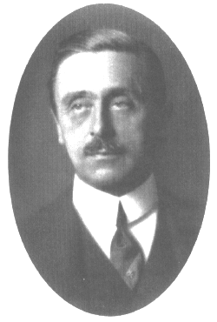
Prof. von Economo

_____

Copyright © August 2005 del autor, como acceso público/ by the author, as Open access. Esta es una investigación de acceso público; su copia exacta y redistribución por cualquier medio están permitidas bajo la condición de conservar esta noticia y la referencia completa a su publicación incluyendo la URL original (ver arriba). / This is an Open Access article: verbatim copying and redistribution of this article are permitted in all media for any purpose, provided this notice is preserved along with the article's full citation and original URL (above).

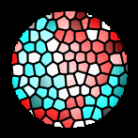

revista
Electroneurobiología
ISSN: 0328-0446

